**Excel Assignment – 6**

**1. What are the various elements of the Excel interface? Describe how they're used.**

The following are the basic parts of the Microsoft Excel Window:

1. Quick Access Toolbar –

This toolbar is located in the upper left corner of the screen. Its objective is to show the most frequently used Excel commands. We can customize this toolbar based on our preferred commands.

1. File Tab –

We can click it to check the Backstage view, where we can open or save files, create new sheets, print sheets, and perform other file-related operations.

1. Title Bar –

The title bar of the spreadsheet is at the top of the window. It displays the active document's name.

1. Control Buttons –

Control buttons are the symbols that are present in the upper-right side of the window, enabling us to change the labels, minimize, maximize, share, and close the sheet.

1. Menu Bar –

Under the diskette or save icon or the excel icon (this will depend on the version of the program), labels or bars which enable changing the sheet which is shown. These are the menu bar and contain a File, Insert, Page Layout, Formulas, Data, Review, View, Help, and a Search Bar with a light bulb icon. These menus are divided into subcategories which simplify the distribution of information and analysis of calculations.

1. Ribbon/Toolbar –

On the selection of the menu, a sequence of command options/icons will show on a ribbon. For example, if we select the "Home" tab, we will see cut, copy, paste, bold, italic, underline, and more commands.

1. Dialog Box Launcher –

Dialog box launcher is a very little down arrow that is present in the lower-right corner of a command group on the Ribbon. By clicking on this arrow, we can explore more options related to the concerned group.

1. Name Box –

Show the location of the active cell, row, or column. We have the option of selecting multiple options.

1. Formula Bar –

Formula bar permits us to observe, insert or edit the information/formula entered in the active cell.

1. Scroll Bars –

Scrollbars are the tools that enable us to move the document's vertical and horizontal views. We can activate this by clicking on the platform's internal bar or the arrows we have on the sides. Additionally, we can use the mouse wheel in order to automatically scroll up or down: or use the directional keys.

1. Spreadsheet Area –

It is the place where we enter our data. It includes all the rows, cells, columns, and built-in data in the spreadsheet. We can use shortcuts to perform toolbar activities or formulas of arithmetic operations (add, subtract, multiply, etc.). The insertion point is the blinking vertical bar known as the "cursor." It specifies the insertion location of the typing.

1. Leaf Bar –

Leaf bar is present at the bottom of the spreadsheet, which says sheet1 is shown. This sheet bar describes the spreadsheet which is currently being worked on. Using this, we can alternate a number of sheets or add a new one as per our convenience.

1. Column Bar –

Columns are a vertically ordered series of boxes across the full sheet. This column bar is located below the formula bar. The letters of the alphabet are used to label the columns. Begin with the letter A to Z, and then after Z, it will continue as AA, AB, and so on. The number of columns that can be used is limited to 16,384.

1. Row Bar –

The row bar is the left part of the sheet where a sequence of numbers is expressed. Begin with number one (1), and further rows will be added as we move the pointer down. There are a total of 1,048,576 rows available.

1. Cells –

Cells are those parallelepipeds that divide the spreadsheet into many pieces, separating rows and columns. A spreadsheet's first cell is represented by the first letter of the alphabet and the number one (A1).

1. Status Bar –

The status bar is present at the bottom of the window that displays critical information. It also indicates whether something is incorrect or whether the document is ready to be printed or delivered.

1. View Buttons –

View buttons are a set of three buttons arranged at the left of the Zoom control, close the screen's right-bottom corner. We can see three different kinds of sheet views in Excel using this method.

Normal View: - Normal view displays the Excel page in normal view.

Page Layout View: - The Page Layout view shows the precise layout of an Excel page it will be printed.

Page Break View: - This displays page break preview before printing.

1. Zoom control –

The zoom control is present at the lower-right side of the window. It enables us to ZOOM-IN or ZOOM-OUT a specific area of the spreadsheet. It is represented by magnifying icons with the symbols of maximizing (+) or minimizing (-).

**2. Write down the various applications of Excel in the industry.**

1. DATA ENTRY AND STORAGE

At its most basic level, Excel is an excellent tool for both data entry and storage. In fact, an Excel file’s size is only limited by your device’s computing power and memory. Worksheets can contain at most 1,048,576 rows and 16,384 columns. So obviously Excel can store a lot of data.

2. COLLECTION AND VERIFICATION OF BUSINESS DATA

Businesses often employ multiple systems (i.e CRM, inventory) each with its own database and logs. All of which can be exported into Excel for easy access.

3. ADMINISTRATIVE AND MANAGERIAL DUTIES

One aspect of managerial duties is creating and outlining business processes. This aids in process optimization and is an effective tool for organizing procedures and scenarios. The use of excel offers tools that allow users to create flow charts, which can include text, pictures, and animations.

4. ACCOUNTING AND BUDGETING

Excel even includes accounting and budgeting templates for easy use. From there the software’s built-in calculating and formula features are available to help you organize and synthesize results.

5. DATA ANALYSIS

Excel can also help you manage and synthesize clear communicable results from it. One of the best features to do this is called Pivot Tables. They allow users to consolidate and focus on certain segments of data from a large data set, creating concise snapshots that can be used as an interactive summary report.

6. REPORTING + VISUALIZATIONS

Data from both raw data sets and Pivot tables can even be used to create charts and graphs. Which can be used for formal reports, presentations, or aid in one’s data analysis. As they can provide another perspective on trends and performance.

7. FORECASTING

While reporting and reviewing results is an important aspect of any business, forecasting and being prepared for various scenarios and changes is just as vital.

**3. On the ribbon, make a new tab. Add some different groups, insert commands in the groups and name them according to their commands added. Copy and paste the screenshot of the steps you followed.**

* Go to File > Options > Customize Ribbon.
* Right-click on the ribbon and select Customize the Ribbon… from the context menu.
* In the Customize the Ribbon window, under the list of tabs, click the New Tab button.

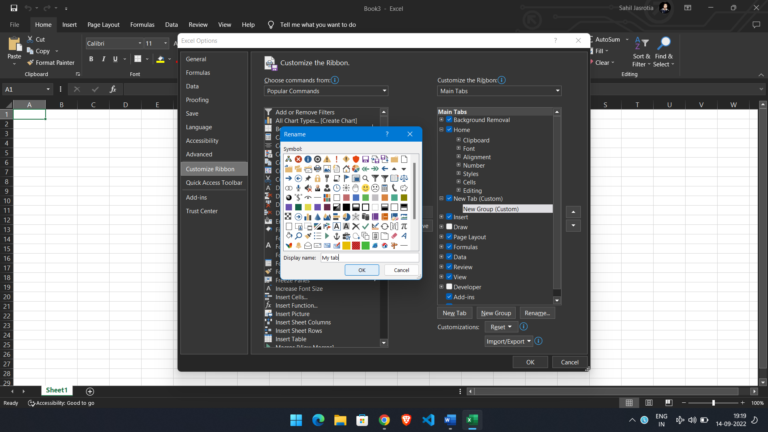

* In the Choose commands from drop-down list on the left, select the list from which you want to add commands, for example, Popular Commands or Commands Not in the Ribbon.
* In the list of commands on the left, click the command you want to add.
* Click the Add button.
* Click OK to save the changes.

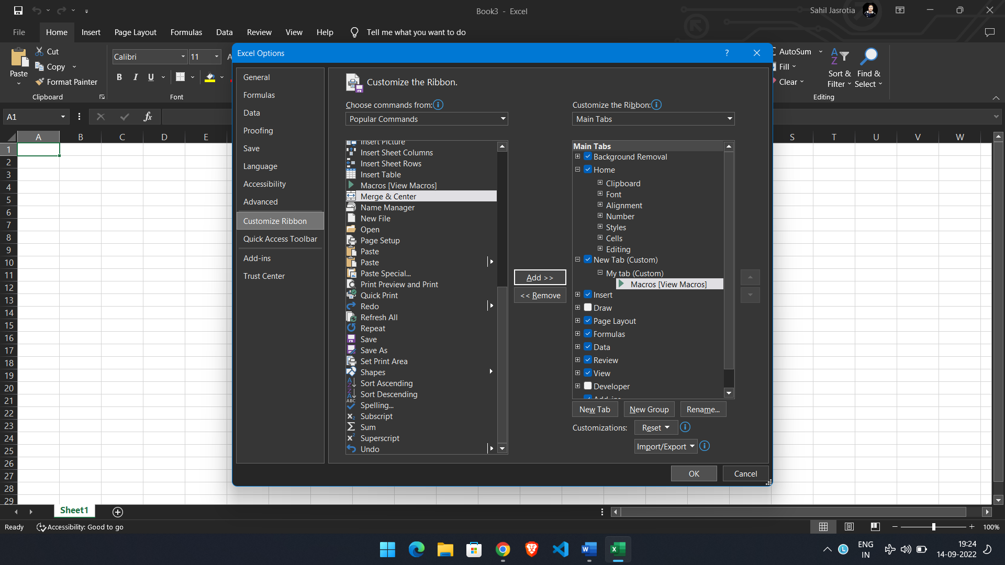

**4. Make a list of different shortcut keys that are only connected to formatting with their functions.**

* Close a workbook - Ctrl+W
* Open a workbook - Ctrl+O
* Go to the Home tab - Alt+H
* Save a workbook - Ctrl+S
* Copy selection - Ctrl+C
* Paste selection - Ctrl+V
* Undo recent action - Ctrl+Z
* Remove cell contents - Delete
* Choose a fill color - Alt+H, H
* Cut selection - Ctrl+X
* Go to the Insert tab - Alt+N
* Apply bold formatting - Ctrl+B
* Center align cell contents - Alt+H, A, C
* Go to the Page Layout tab - Alt+P
* Go to the Data tab - Alt+A
* Go to the View tab - Alt+W
* Open the context menu - Shift+F10 or Windows Menu key
* Add borders - Alt+H, B
* Delete column - Alt+H, D, C
* Go to the Formula tab - Alt+M
* Hide the selected rows - Ctrl+9
* Hide the selected columns - Ctrl+0

**5. What distinguishes Excel from other analytical tools?**

The excel spreadsheet displays financial information in an organized manner. The information could be related to the sales, management department, HR or the marketing. Most of the businesses are dependent on IT sector and therefore excel is a vital tool to run a business.

* It builds the charts
* It makes use of conditional formatting
* It helps to organize the data
* It will identify trends
* It provides online access

Different types of charts like clustered columns, graphs and pie chart provide great visual presentation.

It provides different color shades, font types to format the spreadsheet and differentiate between rows and columns. It is good to present useful presenting information such as balance, tax profit etc.

It offers great online access. The employees as well as the business leaders can have access to this useful program from different location and from various devices. All they need is a web- enabled computer or laptop devices.

**6. Create a table and add a custom header and footer to your table.**

1. Click the **Page Layout** tab.
2. In the "Page Setup" settings, click the **Dialog Box Launcher** button on the right side.

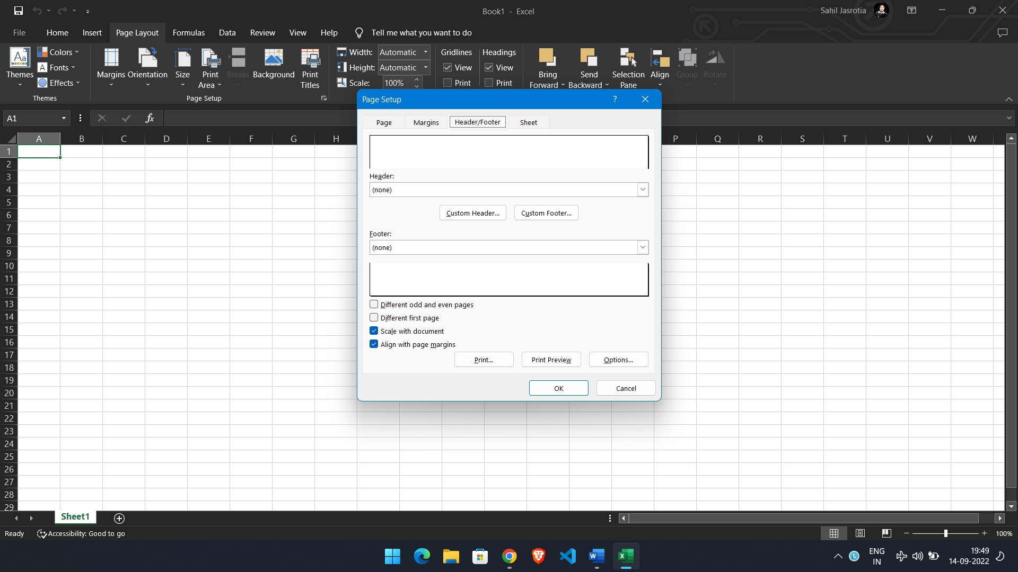

1. Click the **Custom Header** button.

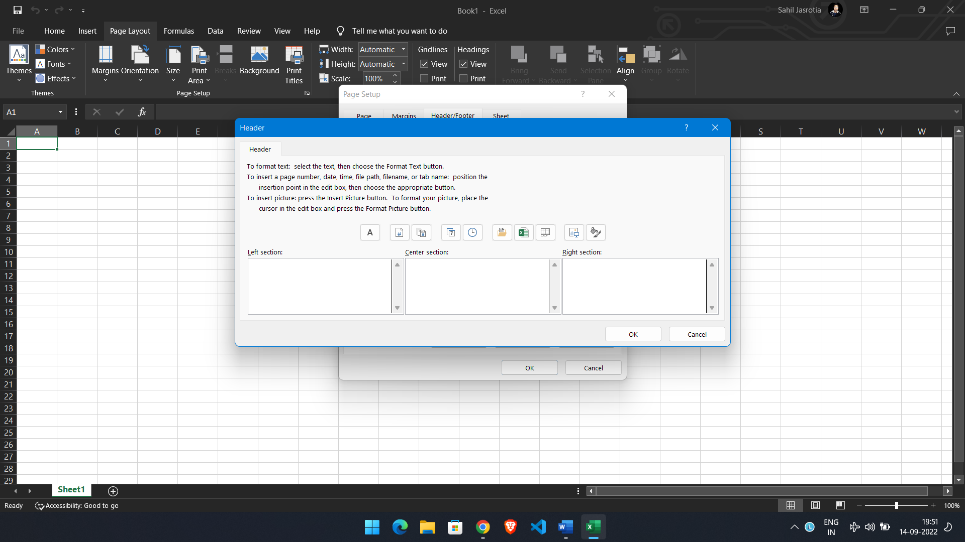

1. Select one of the sections (left, center, or right) to show the header or footer.
2. Compose a line of text for the header or footer.
3. Click the **OK** button.
4. Click the **OK** button again.